Executive Summary
The "Library" feature centralises all user-collected sources (links only) across projects, offering easy access and search capabilities via keywords and tags. It enhances efficiency by allowing users to organise, duplicate, and manage links as a tab in the Unassigned Sidebar.

Target Release | 18/10/2024
Concept Doc | https://docs.google.com/document/d/1q8RaHUQRPODLu0n-BgYlXIw5p71Xp1KDgakITukej1I/edit
Ph2 Doc | https://docs.google.com/document/d/18O0uL5FTn1gXw4fiHRqtoajfXimt9MXZR_4vBa2Ebuk/edit
Figma Link | https://www.figma.com/design/n2FYTev0A6bT7CCK3626BR/Haibrid-DS-v1.2?node-id=8907-24965&t=6njjKdn63f4N9rB9-4
Loom Video
Document Status | {READY}
Owner | Oscar Souchaud

Assumptions
- Users will benefit from a centralised source management instead of relying solely on project-specific collections.
- Search functionality based on keywords from titles or tags will be sufficient for users to locate their links.
- Project names headings above source cards will help users quickly identify and differentiate sources.
- There may be duplicate sources already assigned to projects; handling these edge cases needs consideration.

Requirements
- The new “Library" tab will be added to the “Unassigned”right navigation panel. It will serve as a centralized location to view all sources collected by the user, grouped by project names. Sources will be displayed in collections under "Unassigned" and "Library" tabs, with counts next to each tab.
- Projects listed in the Library should be collapsible, showing only project names.
- Users should be able to search for links using keywords from titles or tags. Search results should be grouped by project names and maintain collapsibility of project sections in search results.
- A drag and drop of a source card should allow users to move sources between projects, edit source details, including:
    - Tags
    - Annotations
    - Source names
    - Include existing tags and annotations when moving sources.
    - Add new tags and notes or edit source names during the move.
- When a source is moved or copied from one project to another project all attributions related to that source, within the new project will be lost.will be lost. Warning modals will notify users when moving or copying attributed sources that the attributions will be lost and that these actions are irreversible.
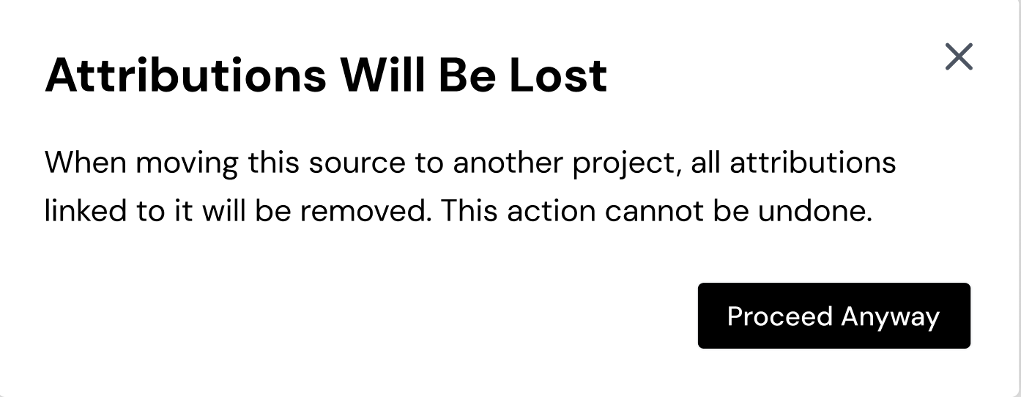
Copy text for Moving source
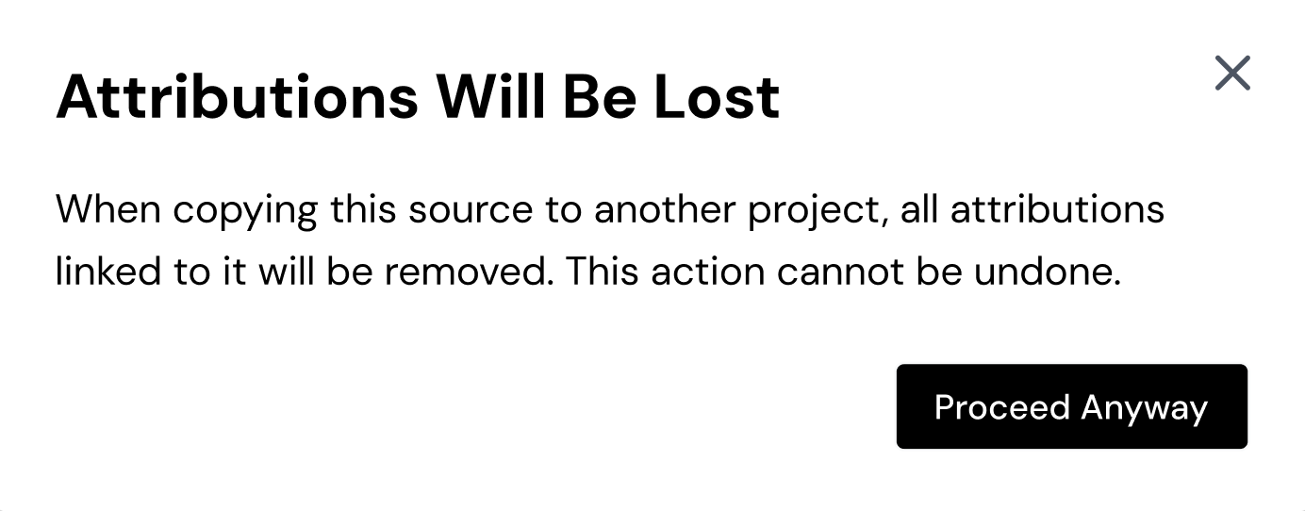
Copy text for Copying source

User Interaction and Micro-interactions Requirements

Right-side Navigation Menu
- When the user opens the right-side navigation menu by clicking on the bookmark icon, they should see two tabs:
  - Unassigned
  - Library
Both tabs should show how many sources are stored in parentheses next to their titles.

Library Tab Content
The user should see all the links they have interacted with under the Library tab, grouped by project names as headings.
The project names should be displayed in recency of creation order, and the user should have the ability to collapse these sections (by using a chevron), showing only project names when collapsed.

Source Search Functionality
When the user searches for a source, the search results should display the project name as a heading to help locate the source easily. The results should remain collapsible as well.

Moving Sources Between Tabs or Projects
When the user attempts to move a source from the Unassigned Sources or Library:
  - A modal should appear asking if they want to include existing tags and annotations.
  - Users should be given the option to add new tags and notes or edit the source name before moving the source.

"Move to" Action from Three Dots Menu
If a user opts to move a source using the "move to" action from the three dots menu:
  - A dropdown should appear where the user can select the project to move the source to.
  - If the source is already attributed in a document within that project, and the user tries to move it to another project, a warning modal should inform them that the attributions will be lost and the action cannot be undone.

Copying Sources Between Projects
If a source is attributed in a document within a project, and the user tries to copy move it to another project:
  - A warning modal should alert the user that attributions will be lost and that this action is irreversible.

Success metrics
Goal | Metric
Simplify source management for users | Reduction in time spent searching for links
Improve workflow efficiency | Increase in the number of sources accessed via the Library
Increase user satisfaction | Positive feedback from users in interviews

Open Questions

- (HTs) The name "All Links" is a bit incorrect, because, for example, if we have the same link in 3 different projects, this link will be shown in "All Links" 3 times. As a result, we will have rather "All Sources with Links" than "All Links".

Answer: Library

- (HTs) We have "Move Source Modal" without options to keep tags and annotations after move, but in the Figma we have another modal, which does the same as "Move Source Modal" with options to keep tags and annotations. I think it will be better to merge these two modals in one and use this one in both cases.

Answer: Modal should be replaced with the new one.

- (HTs) Let's assume the user tries to move a source with link "youtube.com" with tags and annotations to the project, where exists a source with the same link that has its tags and annotations. How should we handle this? Should we remove the old source and keep the new one or the user should receive an error message? I think that we should have a warning modal which will offer different options for this like OS windows has when we try to move a file to the folder containing a file with the same name.
Answer: Newly added tags and any annotations attached to that source should be added to the existing source in the project. Aka sources should be merged. (YM)
And even if the name is edited, the last edit should override the initial name. (NG)

- (HTs) I think we should have a warning modal in case when the user tries to move source which has attributions. Just to inform him that you will lose attributions if you move this source to another place.
Answer: should be a modal with a confirmation of moving.

- (MM) as I understand this modal will appear when the user will try to move a link from all links to some project, am I right? I think we can implement adding tags the same way we did in extension and in dashboard. Also this looks completely like the extension(probably don’t need the header part).

Answer: Adding tags should be consistent across modals. I’m sure this was designed before changes. Thanks for a nice catch. The source thumbnail is ok to stay, as users might want/need to change the source name for the new project.

